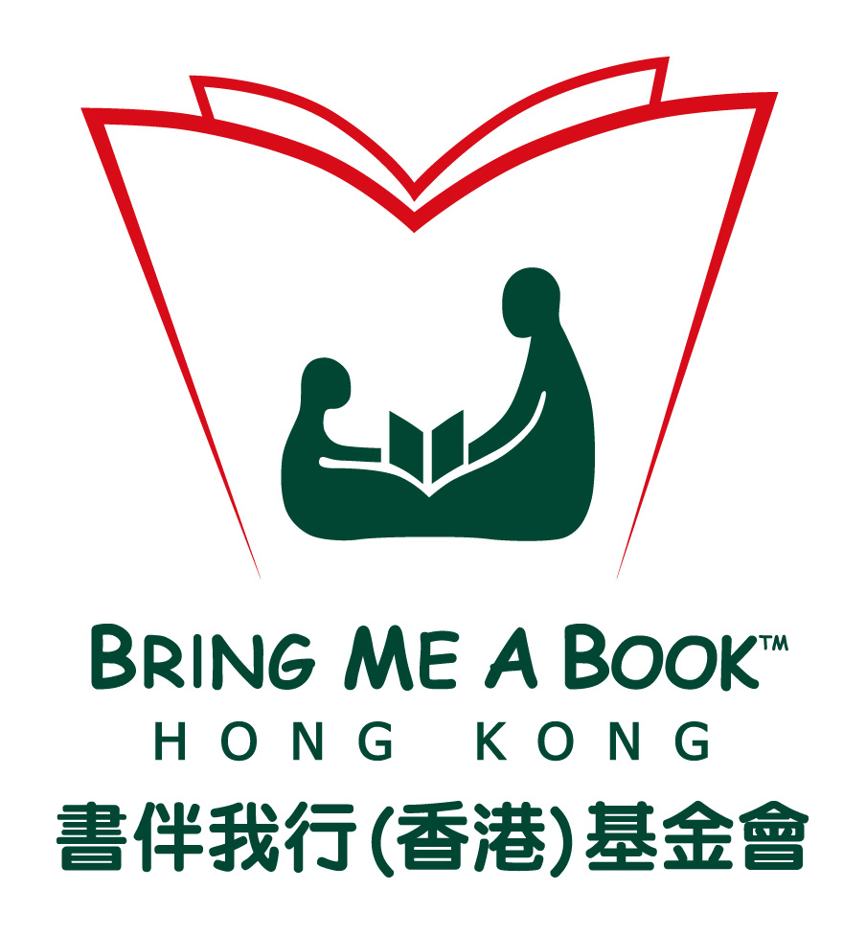
Bring Me A Book Hong Kong – Donation Form 20210826
Donation Form
Inspire a Passion to Read and Bring Books to Children in Need

Date: / / 20

Bring Me A Book™ Hong Kong has identified local pre-schools, primary schools and community centers that would most benefit from otherwise unaffordable quality books and First Teachers™ Training programs. By identifying and screening the schools or centres with the greatest need, we make sure your contribution has the biggest impact.

Donation Options
HK $100 – Quality Book
(Giving 1 quality book to 1 child in need)
HK $500 – Bring Me A Book Pack
(Giving 3 -5 quality books to 1 family in need)
HK $1,000 – Parent Workshop
(Providing specialized training for 1 family to improve child’s interest. Motivation and confidence to read)
HK $2,000 – Find Me A Book
(Support our microsite to offer great book selections and resources)
Other: HK $
Program Donation
HK $19,800 – Install a Large Bookcase
(providing 45 quality children’s books and First Teachers™ Training for parents)
HK $68,800 – Install a Large Book Bag Library
(providing 220 quality children’s books and First Teachers™ Training for parents)

* Our ”First Teachers™ Training” is so named as we believe parents are a child’s first (and best) teacher. This practical training program teaches easy read aloud strategies to implement at home.

Donor Contact Info:
Donor Name /
Organization:
Address:
Phone: |  | Fax:
Email: |  | Website:
If donor information above is different than contact information please complete the section below, otherwise leave the section blank
Contact Name: |  | Email:
Phone: |  | Fax:

Bring Me A Book Hong Kong Limited is a charitable institution and exempt from tax under Section 88 of the Inland Revenue Ordinance. Donations over HK$100 are tax deductible with receipt.
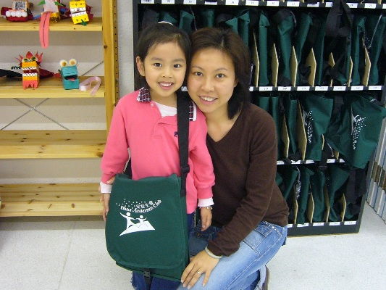
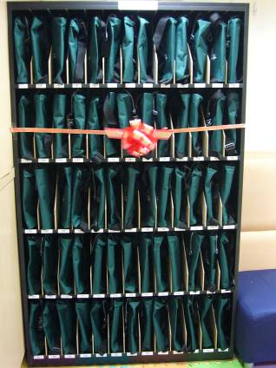
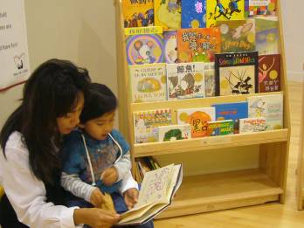

Bookcase Library Book Bag Library
For Bookcase and Book Bag library donors only:
We encourage donors and their families to join the ribbon-cutting ceremony at the beneficiary site (usually a kindergarten, primary school or community center). The ceremony takes 30-45 minutes with the option for the donor to read to the kids making the event extra meaningful and memorable for both parties.

Please complete the following:
Plaque/Bookplate dedication:
- Yes, I would like to make a dedication.
Please fill out the EXACT WORDING of your dedication:
(Examples: In Loving Memory of, In Honor of, A gift from, etc.)
No, I would like my donation to remain anonymous / I do not want any type of dedication.

- Would you like to attend a ribbon-cutting ceremony at the site? Yes No
- Can we share your information with the recipient site? Yes No

Site Selection:
- Have you selected a recipient?
Yes, the name of recipient is:
Contact person: | Phone: | Email:
No, I/We would like BMABHK to choose the site for me, please donate the Library to a/an
Educational Medical/Business Community Service Other:
- Are you interested in supporting future book replenishment at the site? Yes No

Thank you for your kind support!
Please complete this form (also available on our website), and mail together with the crossed cheque payable to “Bring Me A Book Hong Kong Limited” to: Bring Me A Book Hong Kong
21/F Greatmany Centre, 109-115 Queen’s Road East, Wan Chai

For enquiries, please contact us at 2127 4533 or email us at info@bringmeabook.org.hk

